Creating spring boot application

Go to URL: https://start.spring.io/

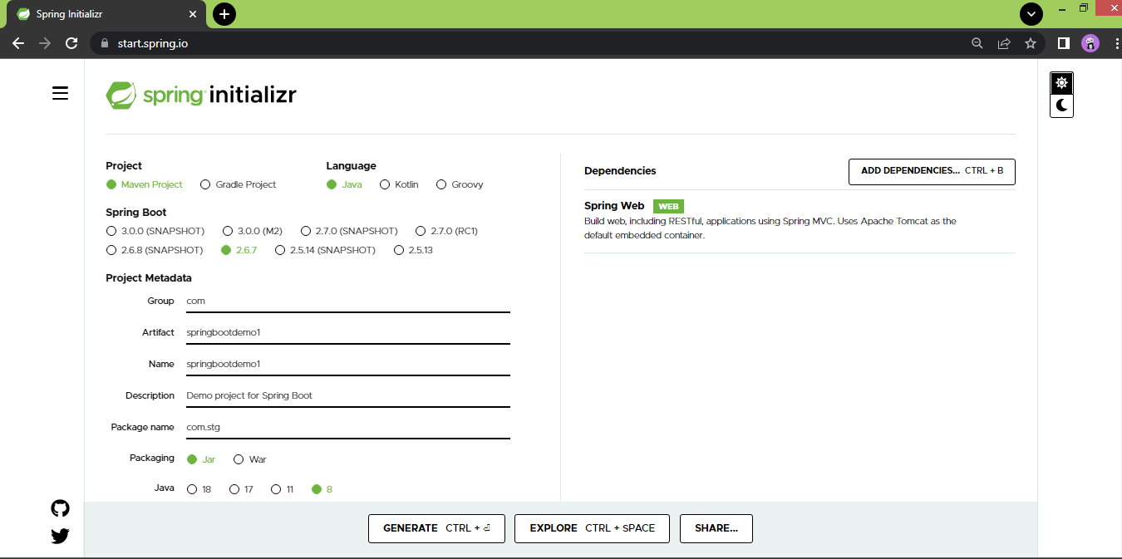

@SpringBootApplication

Many Spring Boot developers like their apps to use auto-configuration, component scan and be able to define extra configuration on their "application class". A single @SpringBootApplication annotation can be used to enable those three features, that is:

@EnableAutoConfiguration: enable [Spring Boot’s auto-configuration mechanism](https://docs.spring.io/spring-boot/docs/2.0.x/reference/html/using-boot-auto-configuration.html)

@ComponentScan: enable @Component scan on the package where the application is located (see [the best practices](https://docs.spring.io/spring-boot/docs/2.0.x/reference/html/using-boot-structuring-your-code.html))

@Configuration: allow to register extra beans in the context or import additional configuration classes